**Assignment 2: Hadoop – Ronald Garcia**

This assignment is based on content discussed in Module 3: Hadoop and Related Tools.

You can answer each question in a word/text file for submission.

**Question 1 (10 Marks)**

Which application(s) are good candidates to run on Hadoop?

a. Multiplayer first-person shooter video game

b. OLAP systems

c. Streaming service like Netflix

d. Banking transactional system ( debits and credits)

e. a and b

f. a and c

g. b and d

**Answer: b. OLAP systems**

**Question 2 (10 Marks)**

Which of the following is not a type of Metadata in the Namenode?

a.List of files

b.Location of the block for files

c.File access control information

d.Number of records in files

e. All of the above.

f. a,b, and c

g. a and b

**Answer: d. Number of records in files**

**Question 3 (10 Marks)**

Which diagram(s) best illustrates a HDFS cluster configuration that has a replication factor of 3 for 3 files.

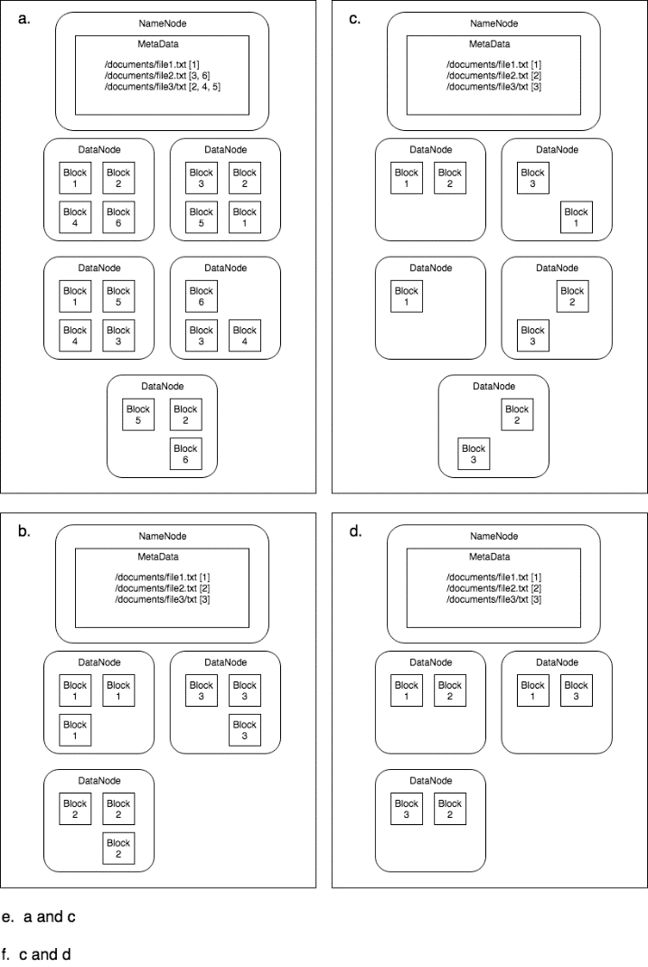

**Answer: e. a and c**

**Question 4 (10 Marks)**

Consider the following input text that contains part of a poem called The Love Song of J. Alfred Prufrock BY T. S. ELIOT:

Time for you and time for me,

And time yet for a hundred indecisions,

And for a hundred visions and revisions,

Before the taking of a toast and tea.

Let’s say we want a word count of this file by creating a MapReduce application. We would split this file into the following four input pairs to four Mapper tasks to consume.

(0, "time for you and time for me")

(1, "and time yet for a hundred indecisions ")

(2, "and for a hundred visions and revisions")

(3, "before the taking of a toast and tea")

What will the input pairs look like for the Reducer tasks? Assume that combiner tasks are used in the MapReduce application.

a.

(time, [1, 1, 1])

(for, [1, 1, 1, 1])

(you, [1])

(and, [1, 1, 1, 1])

(me, [1])

(yet, [1])

(a, [1, 1, 1])

(hundred, [1, 1])

(indecisions, [1])

(visions, [1])

(revisions, [1])

(before, [1])

(the, [1])

(taking, [1])

(of, [1])

(toast, [1])

(tea, [1])

b.

(time, 3)

(for, 4)

(you, 1)

(and, 4)

(me, 1)

(yet, 1)

(a, 3)

(hundred, 2)

(indecisions, 1)

(visions, 1)

(revisions, 1)

(before, 1)

(the, 1)

(taking, 1)

(of, 1)

(toast, 1)

(tea, 1)

c.

(time, [2, 1])

(for, [2, 1, 1])

(you, [1])

(and, [1, 1, 2, 1])

(me, [1])

(yet, [1])

(a, [1, 1, 1])

(hundred, [1, 1])

(indecisions, [1])

(visions, [1])

(revisions, [1])

(before, [1])

(the, [1])

(taking, [1])

(of, [1])

(toast, [1])

(tea, [1])

d. None of the options

**Answer: c.**

**(time, [2, 1])**

**(for, [2, 1, 1])**

**(you, [1])**

**(and, [1, 1, 2, 1])**

**(me, [1])**

**(yet, [1])**

**(a, [1, 1, 1])**

**(hundred, [1, 1])**

**(indecisions, [1])**

**(visions, [1])**

**(revisions, [1])**

**(before, [1])**

**(the, [1])**

**(taking, [1])**

**(of, [1])**

**(toast, [1])**

**(tea, [1])**